Week 2 Security Implementation Report
Name: Dua Eman
Role: Cybersecurity Intern
Organization: Developer Hub Corporation

1. Introduction
This report presents the Week 2 implementation phase of the cybersecurity internship task. The objective was to improve the security posture of the vulnerable Node.js web application by implementing common security controls such as input validation, password hashing, token-based authentication, and secure HTTP headers.

2. Security Measures Implemented
A. Input Validation and Sanitization
The validator library was installed and integrated into the application to validate user inputs.
Implemented Controls:
- Username must be in valid email format.
- Invalid email inputs return HTTP 400 response.
- Email validation added to user profile modification route.
Example:
if (!validator.isEmail(username)) {
return res.status(400).send({ msg: "Invalid email" });
}
Outcome:
Prevents malformed input and reduces risk of injection-based attacks.

B. Password Hashing
The bcrypt library was installed to secure passwords before storing them in the database.
Implemented Controls:
- Passwords hashed using salt rounds = 10.
- Plain text password storage removed.
Example:
const hashedPassword = await bcrypt.hash(password, 10);
Outcome:
Improves password confidentiality and protects against credential exposure.
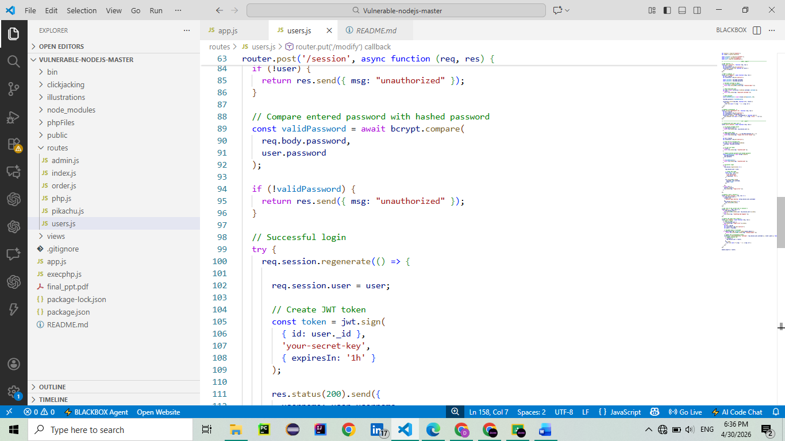

C. Token-Based Authentication
The jsonwebtoken library was implemented for secure login sessions.
Implemented Controls:
- JWT token generated after successful login.
- Token includes user ID.
- Token expiration set to 1 hour.
Example:
const token = jwt.sign(
{ id: user._id },
'your-secret-key',
{ expiresIn: '1h' }
);
Outcome:
Provides modern stateless authentication support.
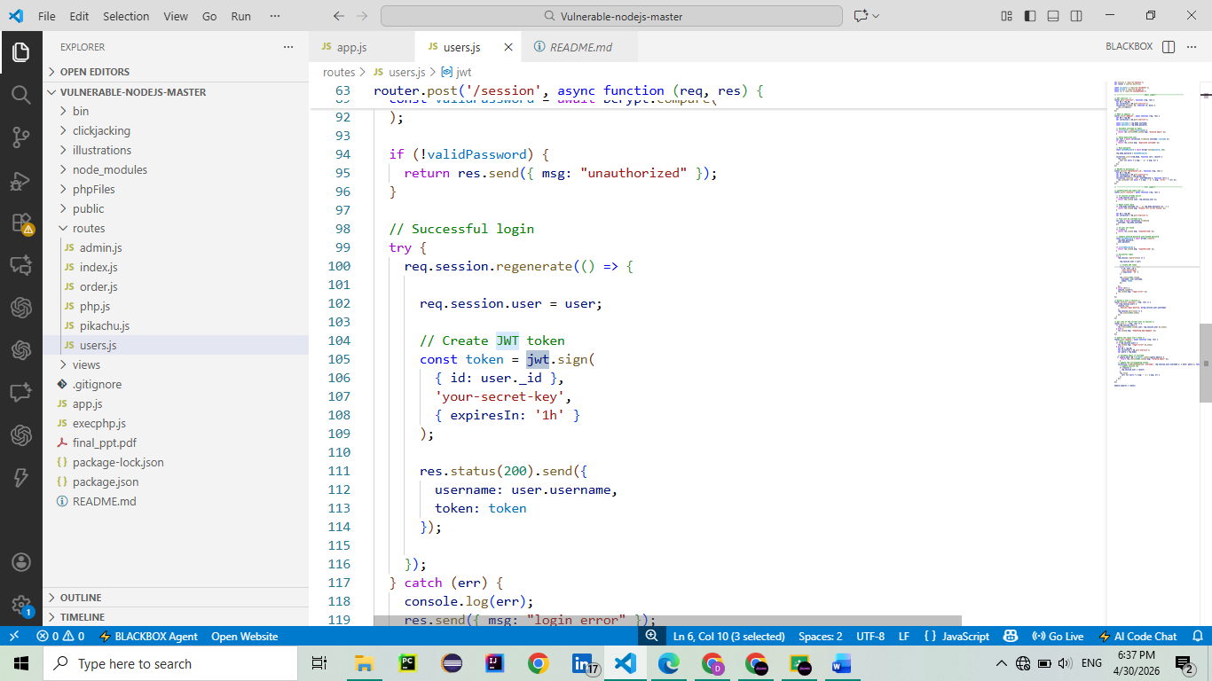

D. Secure HTTP Headers
The helmet middleware was added in app.js to improve browser-side protections.
Implemented Headers:
- X-Frame-Options
- Content-Security-Policy
- X-Content-Type-Options
- Additional browser security headers
Example:
app.use(
helmet({
contentSecurityPolicy: false
})
);
Outcome:
Helps defend against clickjacking, MIME sniffing, and common web attacks.
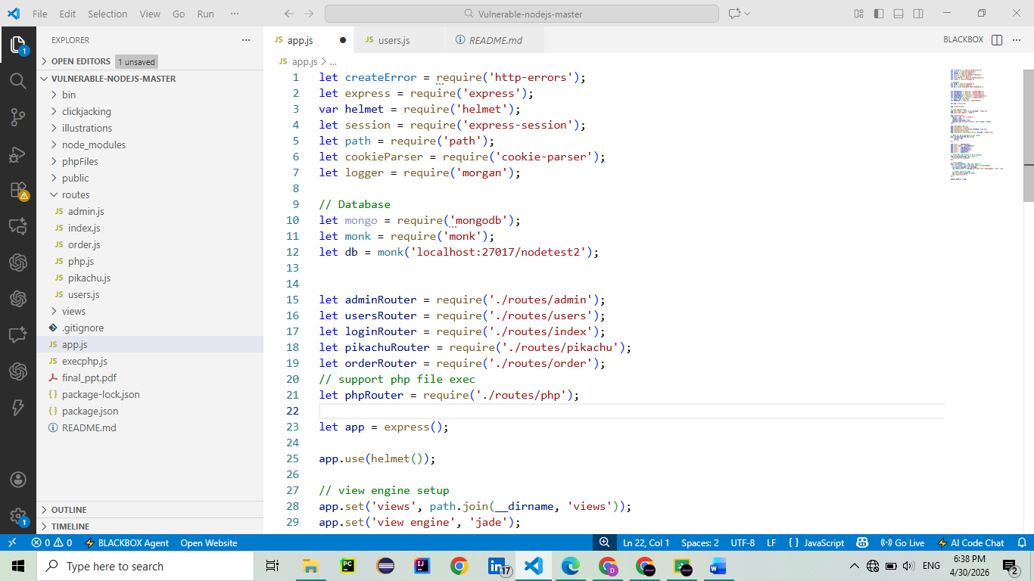

3. Testing Performed
Validation Testing
When invalid username values were submitted during Add User requests, the server returned:
POST /users/adduser 400
This confirmed server-side validation was functioning correctly.
Header Testing
Using browser Developer Tools (Network tab), the following headers were verified:
- X-Frame-Options
- Content-Security-Policy
- X-Content-Type-Options
Login Logic Testing
Application server started successfully after all security changes using:
npm start

4. Issues Encountered
- Legacy frontend JavaScript depended on external CDN resources.
- Helmet CSP initially blocked jQuery loading.
- CSP was adjusted temporarily for compatibility.
- Old project UI did not always display user feedback messages.

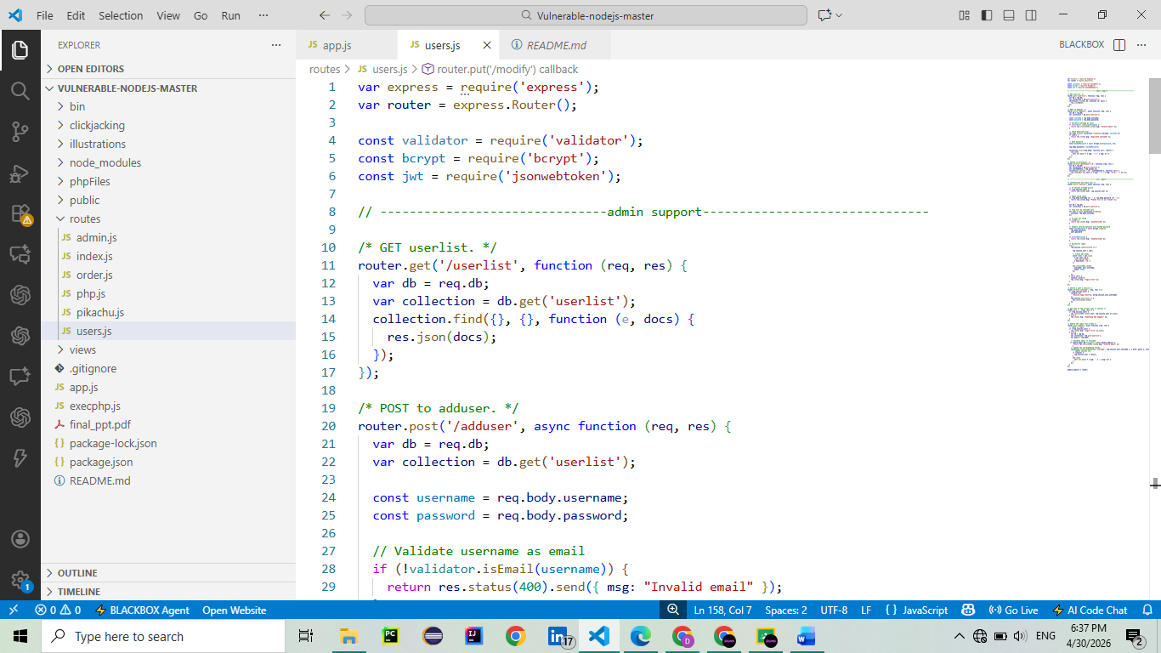


5. Recommendations
- Move from legacy frontend code to modern framework.
- Store JWT secret in environment variables.
- Add stronger password policy.
- Add rate limiting for login attempts.
- Enable HTTPS in production.
- Replace old database libraries with maintained alternatives.
- Improve frontend success/error notifications.

6. Conclusion
Week 2 objectives were successfully completed by implementing key security enhancements in the vulnerable web application. Input validation, password hashing, JWT authentication, and Helmet security headers significantly improved the application’s security model. These controls align with industry best practices for securing Node.js web applications.

7. Tools Used
- Node.js
- Visual Studio Code
- Validator
- Bcrypt
- JSON Web Token (JWT)
- Helmet.js
- Chrome Developer Tools
- GitHub

Submitted By: Dua Eman

